Reporting Services
Chapter
4

Reporter

Requirements

Logical Design

Static Models

The extended report rptReportExT owns a struct that contains (possibly) abstract units of measure. rptUnitValue’s unit of measure refers to the unit of measure in the struct.
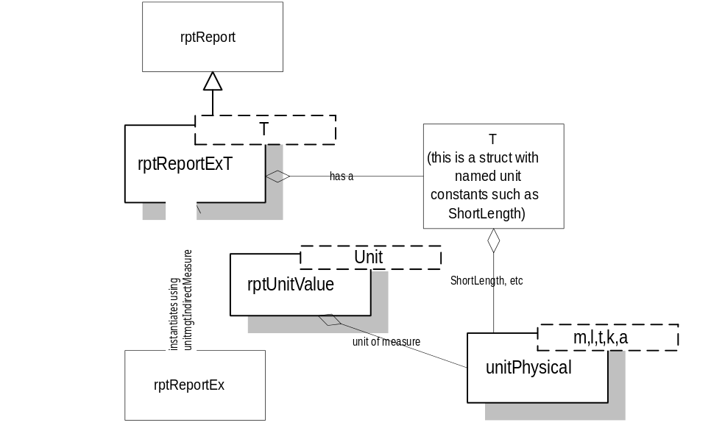

Dynamic Models

Physical Design

Specifications

rptReport
Base class for report. Does what WsRcReport does now.

Public Interface - Member Functions
rptReport
rptReport();
Constructor
What ever else WsRcReport does.

rptReportExT<T>
Derived from rptReport, this is an extended report class. This template class that provides a storage area, of type T, for indirect units of measure.

Public Interface - Member Functions
rptReportTEx
rptReportExT();
Constructor
SetUnitsOfMeasure
void SetUnitsOfMeasure(const T& um);
Sets the units of measure of this report. The rptUnitValue, rptUnitTag, and rptSectionUnitValue objects in the report should refer to the units of measure in um.
GetUnitsOfMeasure
const T& GetUnitsOfMeasure() const;
Returns a constant reference to the units of measure for this report. The rptUnitValue, rptUnitTag, and rptSectionUnitValue objects in the report should refer to the units of measure in this object.

rptReportExt<unitmgtIndirectMeasure> (rptReportEx)
An instantiation of rptReportExT using unitmgtIndirectMeasure as the template argument. For convenience, this class is typedefed to rptReportEx.

rptScalar
Report content for a scalar.

Public Interface - Member Functions
rptScalar
rptScalar(Float64 value);
Constructor
GetValue
Float64 GetValue() const;
Returns the scalar value.
AsString
std::string AsString() const;
Returns the scalar as a string.

rptUnitTagT<>
Report content for a unit tag. This type of report content is useful in table headers where a single unit tag is written for an entire row or column of data. This is a template class that must be instantiated for unitPhysical types.

Public Interface - Member Functions
rptUnitTagT
rptUnitTagT(const T* um);
Constructor. Creates a unit tag object for the unit of measure um.
GetUnitTag
std::string GetUnitTag() const;
Returns the unit tag

Implementation Notes
The unit of measure data member in this report content must be a constant reference to a unitPhysicalT<> object. This is for two reasons. The first is efficiency. Consider a report that has thousands of moment values in it. If every piece of rptRcMoment had a copy of unitMoment, that would be a lot of extra working making the copies and a lot of wasted memory holding onto thousands of identical copies. If all the rptRcMoment objects referred to a unitMoment object then neither the copies or the storage space are needed. The second reason is indirection of units of measure. If the report content refers to a unit of measure, the value of the referred object can be changed and the referring object would get the benefit of the change the next time it is visited.

rptUnitTagT<unitMass> (rptMassUnitTag)
An instantiation of rptUnitTag for units of mass. A typedef name for this unit tag report content is shown in parentheses.

rptUnitTagT<unitLength> (rptLengthUnitTag)
An instantiation of rptUnitTag for units of length.

rptUnitTagT<unitLength2> (rptLength2UnitTag)
An instantiation of rptUnitTag for units of area.

rptUnitTagT<unitLength3> (rptLength3UnitTag)
An instantiation of rptUnitTag for units of volume and section modulus.

rptUnitTagT<unitLength4> (rptLength4UnitTag)
An instantiation of rptUnitTag for units of moments of inertia.

rptUnitTagT<unitTime> (rptTimeUnitTag)
An instantiation of rptUnitTag for units of time.

rptUnitTagT<unitTemperature> (rptTemperatureUnitTag)
An instantiation of rptUnitTag for units of temperature.

rptUnitTagT<unitAngle> (rptAngleUnitTag)
An instantiation of rptUnitTag for units of angle.

rptUnitTagT<unitPressure> (rptPressureUnitTag)
An instantiation of rptUnitTag for units of pressure.

rptUnitTagT<unitStress> (rptStressUnitTag)
An instantiation of rptUnitTag for units of stress.

rptUnitTagT<unitUnitWeight> (rptUnitWeightUnitTag)
An instantiation of rptUnitTag for units of unit weight.

rptUnitTagT<unitDensity> (rptDensityUnitTag)
An instantiation of rptUnitTag for units of density.

rptUnitTagT<unitForce> (rptForceUnitTag)
An instantiation of rptUnitTag for units of force.

rptUnitTagT<unitForcePerLength> (rptForcePerLengthUnitTag)
An instantiation of rptUnitTag for units of force per length.

rptUnitTagT<unitMoment> (rptMomentUnitTag)
An instantiation of rptUnitTag for units of moment.

rptUnitValueT<>
Report content for a united value. This is a template class that must be instantiated for unitPhysical types.

Public Interface - Member Functions
rptUnitValueT
rptUnitValueT(Float64 value, const T* um, Float64 zeroTolerance, bool bShowUnitTag = true );
Constructor. Creates a unit value object for value. value will be converted from System Units to the units of measure specified by um. If the converted value is sufficiently close to zero, as defined by zeroTolerance it will be reported as zero. If bShowUnitTag is true, the unit tag of um will be shown after the converted value, otherwise a unit tag is not shown.
GetValue
Float64 GetValue(bool bConvert = false) const;
Returns the value for this piece of report content. If bConvert is true the value is converted to output units.
GetUnitTag
std::string GetUnitTag() const;
Returns the unit tag for the output unit of measure.
AsString
std::string AsString() const;
Returns the report content as a string. The value is converted to the correct unit of measure and the unit tag is appended to the string if required.
ShowUnitTag
bool ShowUnitTag() const;
Returns true if the unit tag is to be displayed, otherwise returns false.
ShowUnitTag
void ShowUnitTag(bool bShowUnitTag);
If bShowUnitTag is true, the unit tag is displayed, otherwise it is not.

Implementation Notes
See implementation notes for rptUnitTagT<>.

rptUnitValueT<unitMass> (rptRcMass)
An instantiation of rptUnitValueT for units of mass. A typedef name for this united value report content is shown in parentheses.

rptUnitValueT<unitLength> (rptRcLength)
An instantiation of rptUnitValueT for units of length.

rptUnitValueT<unitLength2> (rptRcLength2)
An instantiation of rptUnitValueT for units of area.

rptUnitValueT<unitLength3> (rptRcLength3)
An instantiation of rptUnitValueT for units of volume and section modulus.

rptUnitValueT<unitLength4> (rptRcLength4)
An instantiation of rptUnitValueT for units of moment of inertia.

rptUnitValueT<unitTime> (rptRcTime)
An instantiation of rptUnitValueT for units of time.

rptUnitValueT<unitTemperature> (rptRcTemperature)
An instantiation of rptUnitValueT for units of temperature.

rptUnitValueT<unitAngle> (rptRcAngle)
An instantiation of rptUnitValueT for units of angle.

rptUnitValueT<unitPressure> (rptRcPressure)
An instantiation of rptUnitValueT for units of pressure.

rptUnitValueT<unitStress> (rptRcStress)
An instantiation of rptUnitValueT for units of stress.

rptUnitValueT<unitUnitWeight> (rptRcUnitWeight)
An instantiation of rptUnitValueT for units of unit weight.

rptUnitValueT<unitDensity> (rptRcDensity)
An instantiation of rptUnitValueT for units of density.

rptUnitValueT<unitForce> (rptRcForce)
An instantiation of rptUnitValueT for units of force.

rptUnitValueT<unitForcePerLength> (rptRcForcePerLength)
An instantiation of rptUnitValueT for units of force per length.

rptUnitValueT<unitMoment> (rptRcMoment)
An instantiation of rptUnitValueT for units of moment.

rptUnitSectionValueT<>
Report content for a united section value. This is a template class that must be instantiated for unitPhysical types.

Public Interface - Member Functions
rptUnitSectionValueT
rptUnitSectionValueT(const sysSectionValue value, const T* um, Float64 zeroTolerance, bool bShowUnitTag = true );
Constructor. Creates a unit value object for value. value will be converted from System Units to the units of measure specified by um. If the converted value is sufficiently close to zero, as defined by zeroTolerance it will be reported as zero. If bShowUnitTag is true, the unit tag of um will be shown after the converted value, otherwise a unit tag is not shown.
GetValue
sysSectionValue GetValue(bool bConvert = false) const;
Returns the value for this piece of report content. If bConvert is true the value is converted to output units.
GetUnitTag
std::string GetUnitTag() const;
Returns the unit tag for the output unit of measure.
AsString
std::string AsString() const;
Returns the report content as a string. The value is converted to the correct unit of measure and the unit tag is appended to the string if required.
ShowUnitTag
bool ShowUnitTag() const;
Returns true if the unit tag is to be displayed, otherwise returns false.
ShowUnitTag
void ShowUnitTag(bool bShowUnitTag);
If bShowUnitTag is true, the unit tag is displayed, otherwise it is not.

rptUnitSectionValueT<unitMass> (rptRcSectionMass)
An instantiation of rptUnitSectionValueT for units of mass. A typedef name for this united value report content is shown in parentheses.

rptUnitSectionValueT<unitLength> (rptRcSectionLength)
An instantiation of rptUnitSectionValueT for units of length.

rptUnitSectionValueT<unitLength2> (rptRcSectionLength2)
An instantiation of rptUnitSectionValueT for units of area.

rptUnitSectionValueT<unitLength3> (rptRcSectionLength3)
An instantiation of rptUnitSectionValueT for units of volume and section modulus.

rptUnitSectionValueT<unitLength4> (rptRcSectionLength4)
An instantiation of rptUnitSectionValueT for units of moment of inertia.

rptUnitSectionValueT<unitTime> (rptRcSectionTime)
An instantiation of rptUnitSectionValueT for units of time.

rptUnitSectionValueT<unitTemperature> (rptRcSectionTemperature)
An instantiation of rptUnitSectionValueT for units of temperature.

rptUnitSectionValueT<unitAngle> (rptRcSectionAngle)
An instantiation of rptUnitSectionValueT for units of angle.

rptUnitSectionValueT<unitPressure> (rptRcSectionPressure)
An instantiation of rptUnitSectionValueT for units of pressure.

rptUnitSectionValueT<unitStress> (rptRcSectionStress)
An instantiation of rptUnitSectionValueT for units of stress.

rptUnitSectionValueT<unitUnitWeight> (rptRcSectionUnitWeight)
An instantiation of rptUnitSectionValueT for units of unit weight.

rptUnitSectionValueT<unitDensity> (rptRcSectionDensity)
An instantiation of rptUnitSectionValueT for units of density.

rptUnitSectionValueT<unitForce> (rptRcSectionForce)
An instantiation of rptUnitSectionValueT for units of force.

rptUnitSectionValueT<unitForcePerLength> (rptRcSectionForcePerLength)
An instantiation of rptUnitValueT for units of force per length.

rptUnitSectionValueT<unitMoment> (rptRcSectionMoment)
An instantiation of rptUnitValueT for units of moment.

rptStation
Report content for station values. Stations occur in engineering applications where dealing with surveying data.

Public Interface - Member Functions
rptStation
rptStation(Float64 station, const unitLength& um, Float64 zeroTolerance, const std::string& formatString);

